Artificial Intelligence  
Lab Exercise 7  
Monty Hall Problem

short line

Ashwin Prakash  
RA1911026010048

**Monty Hall Problem:**

The Monty Hall problem is a counter – intuitive statistics puzzle:

* There are 3 doors, which are two goats and a car
* You pick a door hoping it to be a car
* The game show host, examines the other doors and opens one with a goat. (If both doors have goats, he picks randomly.)

**Aim:**

To implement Monty Hall Problem

**Problem Statement:**

To implement the Monty Hal problem through an interactive game played by the user in the terminal window

**Algorithm:**

1. Generate random environments (trials) to guess, and visualize them using Matplolib/Seaborn.
2. Create Stay, switch and door containers.
3. Randomly assign door with a car, and randomly assign a guess for contestant.
4. Host reveals a goat, The host has 2 doors to choose from [contestant_guess == car - door]. If host has only 1 door, then [contestant_guess != car - door]
5. Define the door that the contestant would switch to
6. Record and display the result of switching or staying outcomes

**Program:**

import random

def get_non_prize_door(host, num_doors, player_choice):

  i = 1

  while (i == host or i== player_choice ):

    i = (i+1)%(num_doors)

  return i

def switch_function(shown_door, num_doors, player_choice):

  i = 1

  while (i == shown_door or i== player_choice ):

    i = (i+1)%(num_doors)

  return i

def monty_hall_game(switch, num_tests):

  win_switch_cnt = 0

  win_no_switch_cnt = 0

  lose_switch_cnt = 0

  lose_no_switch_cnt = 0

  doors = [0,1,2]

  num_doors = len(doors)

  for i in range(0,num_tests):

    door_with_prize = random.randint(0, num_doors-1)

    host = door_with_prize

    player_choice = random.randint(0, num_doors-1)

    original_player_choice = player_choice

    shown_door = get_non_prize_door(host, num_doors, player_choice)

    if switch == True:

      player_choice = switch_function(shown_door,num_doors, player_choice)

    if player_choice == host and switch == False:

      print('Player Wins (No switch) - The player chose door: ', player_choice,' Original choice: ',original_player_choice ,', Door with prize:', door_with_prize, ', Shown Door: ',shown_door )

      win_no_switch_cnt = win_no_switch_cnt + 1

    elif player_choice == host and switch == True:

      print('Player Wins (switch) - The player chose door: ', player_choice,' Original choice: ',original_player_choice , ', Door with prize:', door_with_prize, ', Shown Door: ',shown_door )

      win_switch_cnt = win_switch_cnt +1

    elif player_choice != host and switch == False:

      print('Player Lost (No switch) - The player chose door: ', player_choice,' Original choice: ',original_player_choice , ', Door with prize:', door_with_prize, ', Shown Door: ',shown_door )

      lose_no_switch_cnt = lose_no_switch_cnt + 1

    elif player_choice != host and switch == True:

      print('Player Lost (switch) - The player chose door: ', player_choice,' Original choice: ',original_player_choice , ', Door with prize:', door_with_prize, ', Shown Door: ',shown_door )

      lose_switch_cnt = lose_switch_cnt + 1

    else:

      print('SOMETHING IS WRONG')

  return win_no_switch_cnt,win_switch_cnt,lose_no_switch_cnt,lose_switch_cnt, num_tests

x = monty_hall_game(True,3)

**Output:**

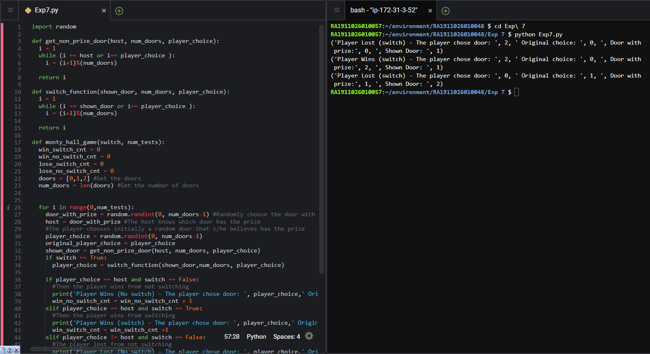

**Observations:**

By Manual Calculation,

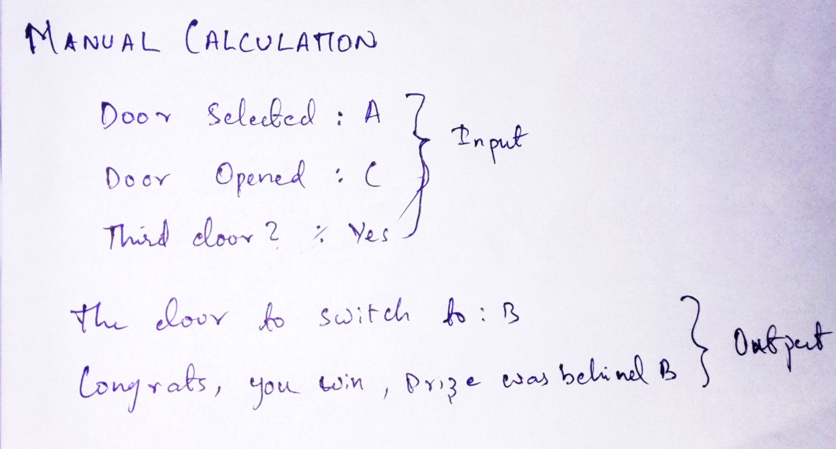

**Inference:**

The Monty Hall Problem was implemented successfully through a game of choosing doors and winning a car in the end.

**Result:**

Monty Hall problem is implemented successfully.